ACA Module 10 Lab Automating Infrastructure Deployment with AWS CloudFormation

____________________________________________________

COS 20019- Cloud Computing Architecture

Nguyen Manh Dung

30/6/2023

So this all my step to finish ACA Module 9 Lab with explanation with all the screenshotted is included a requirement of the project

**Task 1: Deploying a networking layer**

**Create stack consist 4 steps (including download the newwork file)**

**Step 1:** Specify template

**Template source:** Upload a template file

Upload a template file: Click Choose file then select the lab-network.yaml file that you downloaded.

**Step 2:** Create Stack

**Stack name:** lab-network

**Step 3:** Configure stack options

In the **Tags** section, enter these values.

**Key**: application

**Value**: inventory

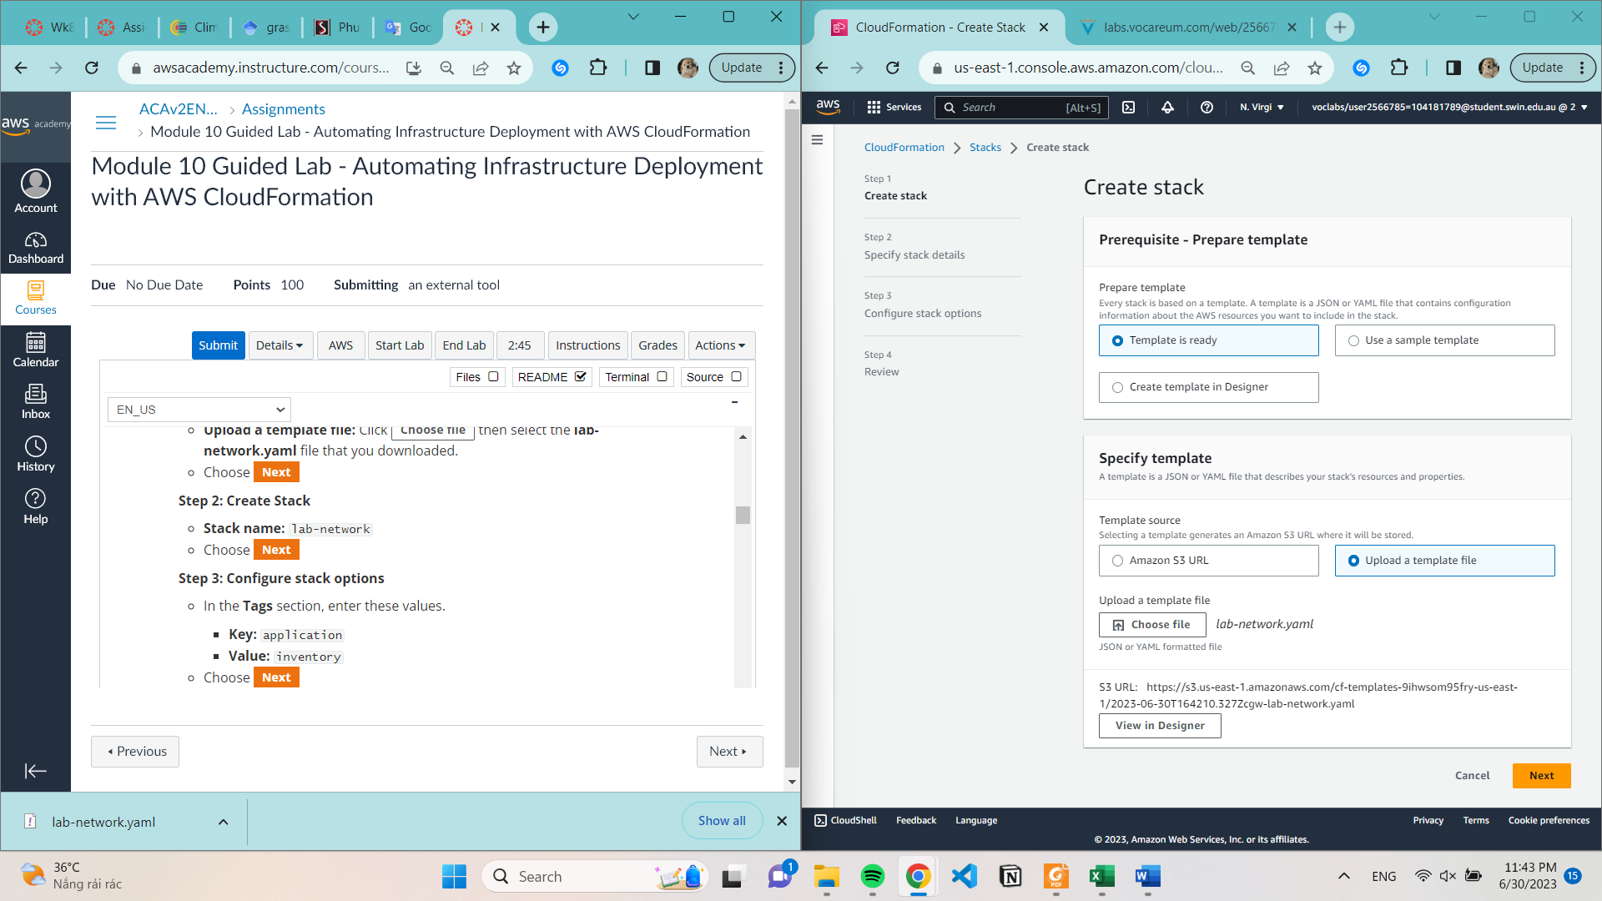

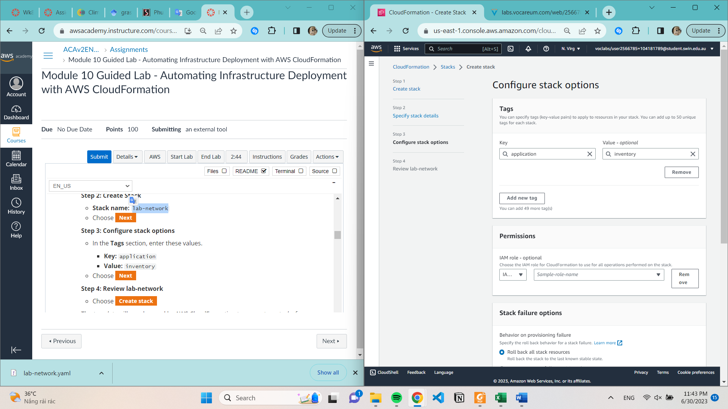

**Task 2: Deploying an application layer**

**We did the same task like Task 1 but with different file**

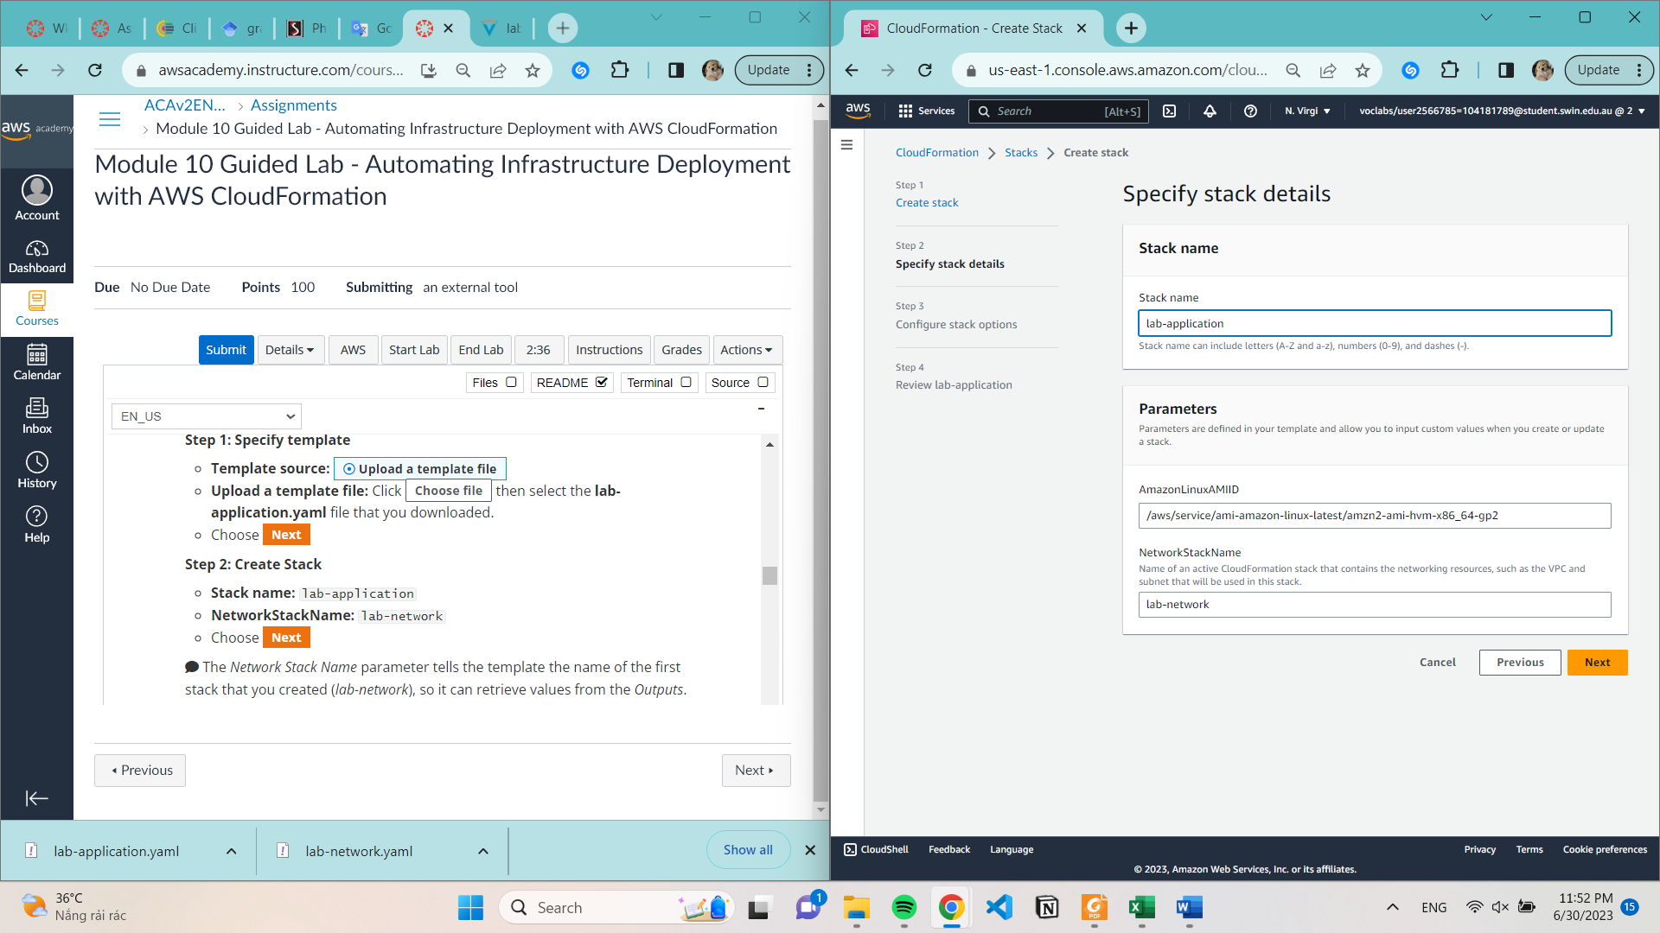

**.**

**Task 3: Updating a Stack**

**Examine Security group**

**Update Cloudformation template**

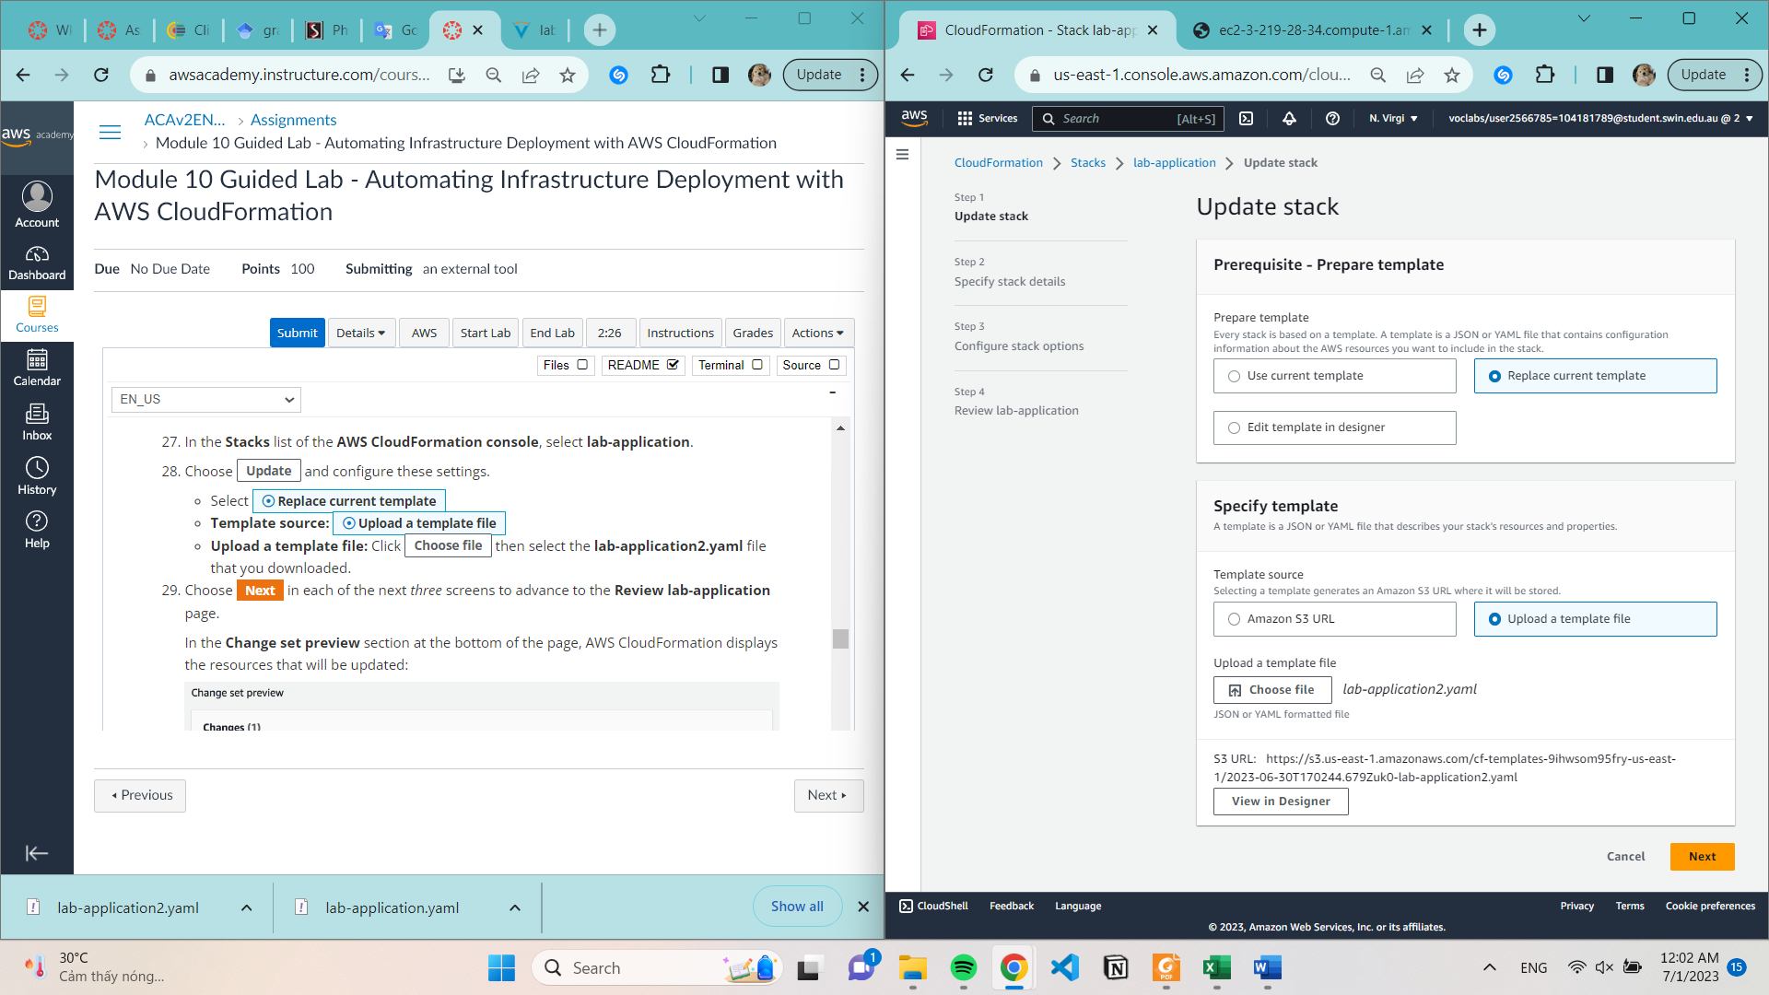

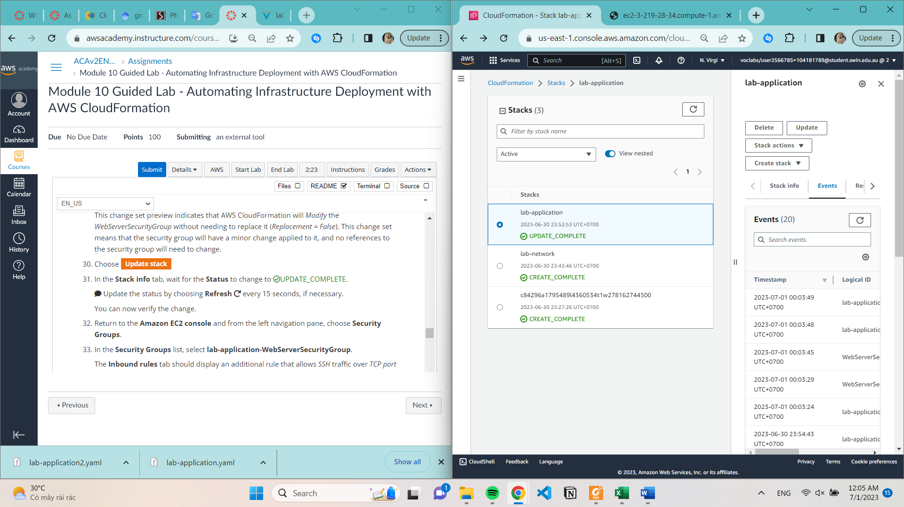

**Task 4: Exploring templates with AWS CloudFormation Designer**

**Task 5: Deleting the stack**

**Snapshots with Started time**

